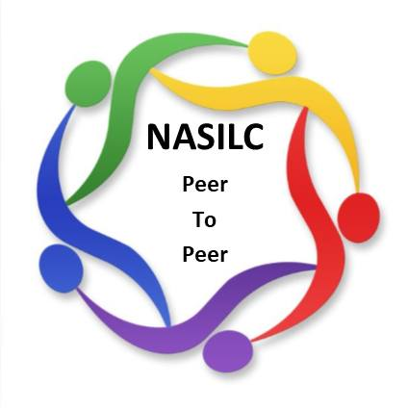
Conference Sponsorship Opportunity
SILC Congress 2026
March 16th – 19^{th,} 2026
Rosen Centre in Orlando, Florida
National Association of Statewide Independent Living Councils
The National Association of Statewide Independent Living Councils (NASILC) plays a crucial role in supporting and strengthening the network of Statewide Independent Living Councils (SILCs).
SILC Congress is the only National Conference for SILCs. Your sponsorship and participation provide you with a unique opportunity to connect with the leaders of 56 states and territories.
2026 Sponsorship Opportunities
Changemaker Sponsorship $10,000 Sponsorship
- Acknowledgment during conference opening and closing sessions
- Custom message from company shared during conference
- Company logo displayed during breaks and lunches
- Full page advertisement in conference program
- Complimentary exhibitor table
- Sponsorship listed with website link on conference website
Access Champion Sponsorship $7,500 Sponsorship
- Acknowledgment during conference closing session
- Company logo displayed during breaks
- Quarter page advertisement in conference program
- Complimentary exhibitor table
- Sponsorship listed with website link on conference website
Community Catalyst Sponsorship $5,000 Sponsorship
- Acknowledgment in conference program
- Sponsorship listed with website link on conference website
- Complimentary exhibitor table
IL Supporter Sponsorship $750 Sponsorship
- Acknowledgment in conference program
- Sponsorship listed with website link on conference website
Custom Sponsorship $______ Sponsorship
Sponsoring Organization Click or tap here to enter text.
Contact Person Click or tap here to enter text.
Email Click or tap here to enter text.
Phone Number Click or tap here to enter text.
Sponsorship Level:
☐ Changemaker ☐ Access Champion ☐ Community Catalyst ☐ IL Supporter ☐ Custom Sponsor

