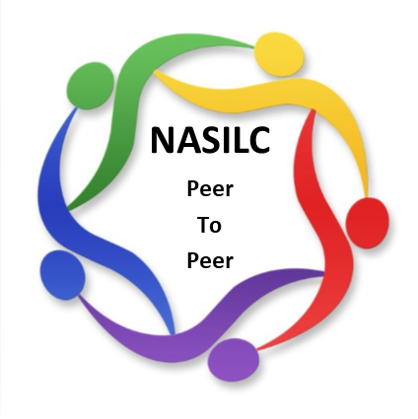

*Mission: To provide resources to SILCs across the nation and promote collaboration with their partners to advance IL values and philosophy.*

**NASILC Board of Directors Meeting Agenda**

**July 28, 2025 –**

**10:00 AM Pacific, 11:00 AM Mountain, 12:00 PM Central, 1:00 PM Eastern**

Register in advance for this meeting:

<https://zoom.us/meeting/register/1Ienfb7QT_u1W5kaONRvuA>

Call to Order Brooke Wilson

Board member Roll Call Gloria Garton

Member Comment (3 minutes) Brooke Wilson

Approval of April 28, 2025 Meeting Minutes Gloria Garton

Treasurer Report – 990 review Jeremy Morris

* Finance Report
* 990 Review

Committee Reports

Bylaws & Policies & Procedures – Finance Policies Mel Leviton

Advocacy & National Strategy Gloria Garton

Membership & Nominations Mellie Adu

Conference Planning – 2026 SILC Congress Jami Davis

Region Representatives Carrie England

Partner Updates Brooke Wilson

T/TA contract

Collaborations-Contracts

General Updates All

Adjourn

\***Next meeting scheduled for October 27, 2025**