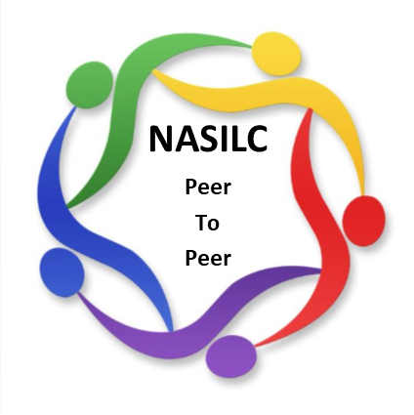
Mission: To provide resources to SILCs across the nation and promote collaboration with their partners to advance IL values and philosophy.

NASILC Board of Directors Meeting Agenda
October 27, 2025 –
10:00 AM Pacific, 11:00 AM Mountain, 12:00 PM Central, 1:00 PM Eastern

Register in advance for this meeting:
https://zoom.us/meeting/register/1Ienfb7QT_u1W5kaONRvuA

Call to Order Brooke Wilson

Board member Roll Call Gloria Garton

Member Comment (3 minutes) Brooke Wilson

Approval of July 28, 2025 Meeting Minutes Gloria Garton

Treasurer Report Jeremy Morris
- Finance Report 9.30.25
- FY2026 Budget

Committee Reports
Bylaws & Policies & Procedures Mel Leviton
Advocacy & National Strategy Gloria Garton
Membership & Nominations Mellie Adu
Conference Planning – 2026 SILC Congress Jami Davis
Region Representatives Carrie England

Partner Updates Brooke Wilson

T/TA contract
Collaborations-Contracts
General Updates All

Adjourn

*Next meeting scheduled for January 26, 2026

